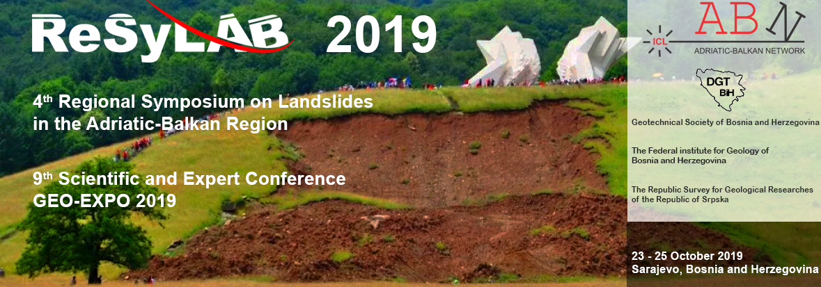

Invitation

On behalf of the Geotechnical Society of Bosnia and Herzegovina, The Federal Institute for Geology of Bosnia and Herzegovina and The Republic Survey for Geological Researches of the Republic of Srpska, we are pleased to invite you to take part in the 4th Regional Symposium on Landslides in the Adriatic-Balkan Region - ReSyLAB 2019 Sarajevo.
The symposium will be held from 23rd to 25th of October 2019 at the Holiday hotel in Sarajevo, Bosnia and Herzegovina.

The aim is to gather the International Consortium on Landslides Adriatic-Balkan Network (ICL ABN) members, experts, professionals and researchers from the countries in the Adriatic-Balkan region and world-wide, concerned with landslides, hazard and risks.

We look forward to welcoming you to ReSyLAB 2019 in Sarajevo.

Best Regards,

Prof. dr. Mato Uljarević
President of the Geotechnical Society of Bosnia and Herzegovina
On behalf of Organizing Committee of 4th Regional Symposium on Landslides in the Adriatic-Balkan Region - ReSyLAB 2019
Symposium Theme
The ReSyLAB 2019 is an opportunity for the scientists, engineers and professionals to present papers and case studies related to:
- the landslides
- mapping
- investigation
- monitoring
- mitigation of landslides' impact on the environment and living.
The official language of the ReSyLAB is English.

GEO-EXPO 2019
The conference topics are related to geotechnics. The official languages of the Geo-EXPO conference are Bosnian, Croatian, Serbian and English.
Important Dates

Paper title submission  Abstract submission  Abstract acceptance  Full paper submission  Symposium  Field study tour | August 1 – November 1, 2018  October 15, 2018  January 15, 2019  April 15, 2019  October 23 – 24, 2019  October 25, 2019
Abstract and Full Paper Submission
All symposium participants are invited to submit the full paper, to be peer- reviewed and published in the symposium proceedings. The keynote lectures and selected papers will be published in the proceedings of the 4th Regional Symposum on Landslides in the Adriatic-Balkan Region.
Instructions for the preparation of abstract and full paper (4-6 pages) will be
both sent to authors by e-mail and available on the website.
Preliminary ReSyLAB 2019 Programme

23 October 2019 | 24 October 2019 | 25 October 2019
Symposium registration  Symposium opening  Oral presentations  Poster session  Social evening | Oral presentations  The ISL ABN Round table | Field study tour
Initial Organizing Committee
Prof. Mato Uljarević
Prof. Bojana Grujić
Prof. Maja Prskalo
Prof. Azra Špago
Prof. Sabid Zekan
Amer Džindo
Hazim Hrvatović
Ferid Skopljak
Dragan Mitrović
Cvjetko Sandić
Sabrina Salković
Venue
ReSyLAB 2019 is to be held at the hotel Holiday in the very center of Sarajevo http://www.hotelholiday.ba/en/
Registration Fees and Deadlines
The registration fee for all participants is 120 EUR, except for the members of the Geotechnical Society of Bosnia for whom it is 80 EUR. The registration fee includes symposium proceedings, coctail refreshments and symposium dinner.
Payment instructions for registration fee are available on the symposium website:
http://www.geotehnika.ba/ReSyLAB2019/
Contact
geotehnika@geotehnika.ba

